**Product Name and brief description:**

**MUTUAL FUNDS:**

Mutual Funds are investment vehicles made up of a pool of funds collected from investors for the purpose of investing in securities such as bonds, money markets instruments, Sukuks, stock markets and other financial securities.

**Product Feature and Benefits:**

1. Well regulated and transparent
2. Variety of investment avenues
3. Choices of receiving income/profits
4. Professional money management
5. Affordable Investment
6. Diversification with small values
7. Minimum paper work
8. Tax benefits

**FAQs**

**Are Returns in Mutual Funds Guaranteed?**

No the returns in Mutual Funds are not guaranteed. The returns may fluctuate depending on the underlying market performance.

**Can I lose money in investments in Stock Funds?**

Yes your invested amount may decrease if you invest in stock funds if the market is experiencing a downturn. However if you invest in low risk funds the principal amount will not decrease.

**Is there a minimum investment period for Mutual Funds?**

No. You can redeem your investment and any profit at any time, generally there is no minimum investment period.

**Will I Get cash when I redeem or take out my investment from my mutual fund?**

No. It will be credited in you account or provided in form of a cheque.

Product Type

**1-Equity Schemes:**

An equity scheme or equity fund is a fund that invests in Equities more commonly known as stocks. The objective of an equity fund is long-term growth through capital appreciation, although dividends and capital gain realized are also sources of revenue.

Currently Offers:

* Alfalah GHP Alpha Fund
* Alfalah GHP Stock Fund
* Alfalah GHP Islamic Stock Fund.

**2-Balanced Schemes:**

These funds provide investors with a single mutual fund that invests in both stocks and debt instruments and with this diversification aimed at providing the potential upside from equity investments, while providing stability of returns through fixed income investments. Between 30% to 70% of net assets have to remain invested in listed equity securities at all times.

**3-Asset Allocation Scheme:**

These Funds may invest their assets in any type of securities at any time in order to diversify their assets across multiple types of securities & investment styles as specified in their Offering Document.

Currently Offers: Alfalah GHP Value Funds

**4-Fund of Funds Scheme:**

Fund of Funds – also known as ‘Managing the Manager’ - are those funds which invest in other mutual funds. Other categories of funds are not allowed to invest in mutual funds, only Fund of Funds schemes can do that.

Currently Offers:

* Alfalah GHP Islamic Prosperity Planning Fund
* Alfalah GHP Islamic Active Allocation Plan II
* Alfalah GHP Islamic Active Allocation Plan III
* Alfalah GHP Islamic Balance Allocation Plan
* Alfalah GHP Islamic Moderate Allocation Plan
* Alfalah GHP Prosperity Planning Fund
* Alfalah GHP Active Allocation Plan
* Alfalah GHP Conservative Allocation Plan
* Alfalah GHP Moderate Allocation Plan

**5-Capital Protected Scheme:**

Capital Protected Funds make investments in such a manner that the original amount of investment is protected/guaranteed. Such funds, while categorized as open-ended, are for a limited duration, and the capital protection is only valid if the investment is held till the maturity of the fund.

Currently Offers:

* Alfalah Capital Preservation Fund II
* Alfalah GHP Islamic Prosperity Planning Fund
* Capital Preservation Plan IV
* Capital Preservation Plan V

**6-Income Scheme:**

These funds focus on providing investors with a steady stream of fixed income. They invest in short term and long term debt instruments like TFCs, government securities like T-bills/PIBs, or Term Deposit Receipts (TDRs). The fund can only invest in at least investment grade instruments. The weighted average time to maturity of net assets cannot exceed 4 years.

Currently Offers:

* Alfalah GHP Sovereign Fund
* Alfalah GHP Income Fund
* Alfalah GHP Islamic Income Fund

**7-Money Market Schemes:**

Money Market Funds are among the lowest risk of the different categories of mutual funds. These funds invest in short term debt instruments such as Treasury bills and bank deposits. The weighted average time to maturity of the net assets cannot exceed 90 days.

Currently Offers:

* Alfalah Money Market Fund
* Alfalah GHP Income Fund

**8-Shariah Compliant (Islamic) Scheme:**

Islamic funds are those funds which invest in Shariah  Compliant securities i.e. shares, Sukuk, Ijarah sukuks  etc. as may be approved by the Shariah Advisor of  such funds. These funds can be offered under the same categories as those of conventional funds, i.e.  Every conventional scheme can have an equivalent Shariah Compliant scheme.

Target Market

Investments can be made by visiting/ contacting as or through online channels using the Alfa App**.**

1. Individual
2. Corporate Investors

Eligibility Criteria

* Investor must be a Pakistan Passport holder
* Investor shall only make investment in PKR

Documentation Required

**For Individuals:**

* Account Opening Form
* Investment Form
* Cheque/Online Transfer Slip/RTGS Letter
* Copy of Valid CNIC/NICOP/Passport
* Any Documentary evidence providing reasonable assurance in identifying the SOURCE of funds (Also required for Joint Holder in any)
* Zakat Affidavit (In case of Zakat exemption)
* Copy of Nominee(s) Valid CNIC/NICOP/Passport
* Copy of Joint Holder(s) Valid CNIC/NICOP/Passport
* Business / Employment Proof (Also required for Joint Holder if any)
* W-9 Form (U.S Citizen)
* W-8BEN Form (U.S Citizen)

**For Corporates:**

List of Authorized Signatories with specimen signatures on company letter head OR certified copy

**For Partnership:**

* Detail of Partners ( Name, Address, Phone Numbers)
* Copy of valid CNIC of all partners
* Copy of Laters Financial statements
* Certified copy of partnership Deed.

**For  Joint Stock Company/Trust:**

* Copy of valid CNIC of all Directors/Trustees
* Copy of Laters Financial statements (Audited)
* Certified copy of Memorendum and Articles of Association/Trust Deed
* Board/Trustee/Governing Body Resolution

**For  Club Societies and Associations**

* Certified copy of Certification of registration
* Certified copy of by Laws/Rules and Regulations
* Copy of Laters Financial statements
* Board/Trustee/Governing Body Resolution

**For  Executors/Administrators:**

* Copy of Valid CINCs of all Executors/Administrators
* Certified copy of Letter of Administration

Note: Tax and Zakat Exemption Certificates/Affidavit are mandatory if exempted.

Registration Process

* [Product  
  Features](https://baflearn.bankalfalah.com/local/kp/?viewpage=9&level=2&cmid=68#pf)
* [Product  
  Types](https://baflearn.bankalfalah.com/local/kp/?viewpage=9&level=2&cmid=68#pt)
* [Target  
  Market](https://baflearn.bankalfalah.com/local/kp/?viewpage=9&level=2&cmid=68#tm)
* [Eligibility  
  Criteria](https://baflearn.bankalfalah.com/local/kp/?viewpage=9&level=2&cmid=68#ec)
* [Documentation  
  Required](https://baflearn.bankalfalah.com/local/kp/?viewpage=9&level=2&cmid=68#dr)
* [Registration  
  Process](https://baflearn.bankalfalah.com/local/kp/?viewpage=9&level=2&cmid=68#rp)
* [Associated  
  Charges](https://baflearn.bankalfalah.com/local/kp/?viewpage=9&level=2&cmid=68#ac)
* [Related  
  TATs](https://baflearn.bankalfalah.com/local/kp/?viewpage=9&level=2&cmid=68#rtt)
* [Others](https://baflearn.bankalfalah.com/local/kp/?viewpage=9&level=2&cmid=68#ot)

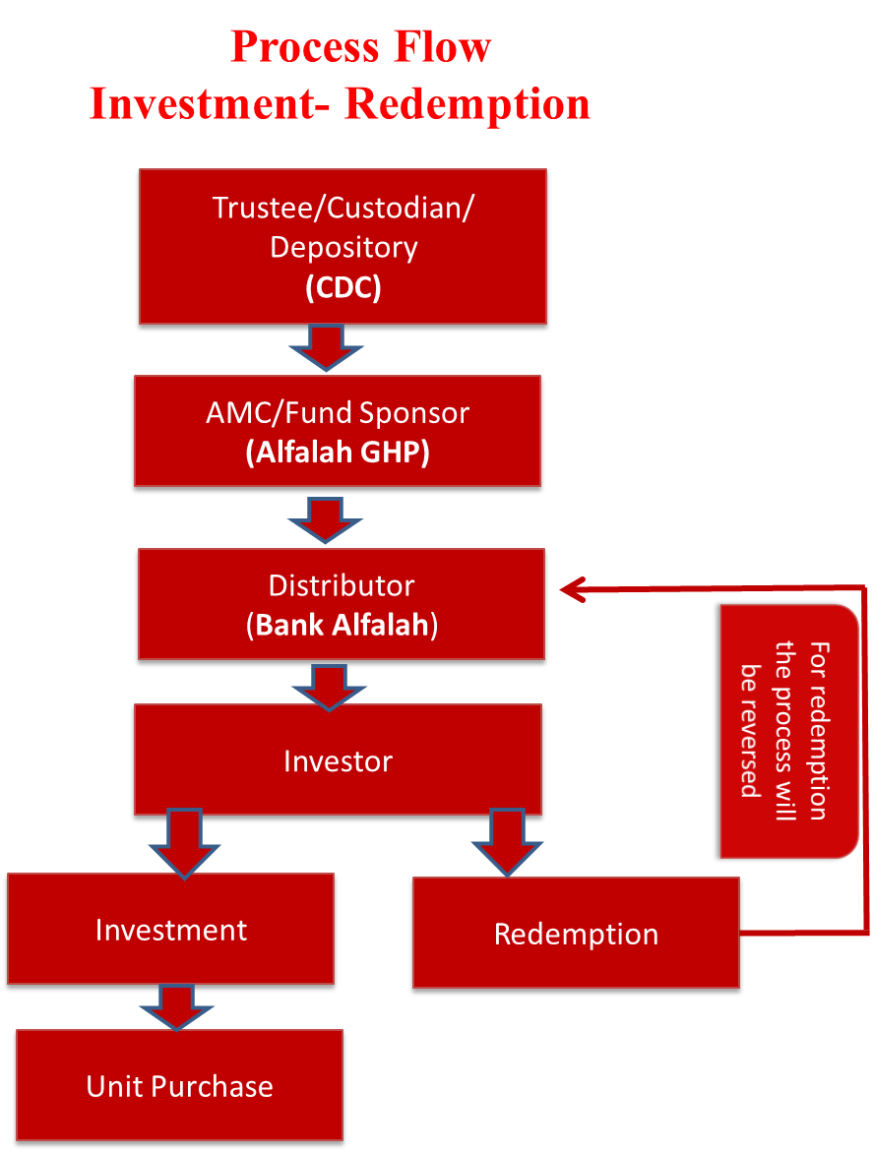

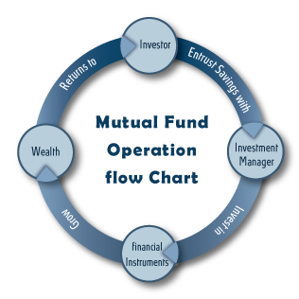

Associated Charges

Following are a few costs (transaction specific) which an investor has to bear when he invests with a mutual fund, namely:

* “Sales Load” this charge is applicable to investors when they purchase units.
* “Management Fee” this charge is an Annual Fee payable by the mutual fund to the management company for managing the mutual fund. As per NBFC Rules an asset management company can charge upto 3% of the average net annual assets of the fund for the first five years of its operations and then upto 2% of such average net annual assets.

The above mentioned costs are subject to change from time to time after meeting the necessary regulatory approvals and formalities as required.

Related TATs

|  |  |
| --- | --- |
| **Description** | **TAT** |
| Investment | 3 Working Days |
| Redemption | 3 Working Days |
| Conversion | 2 Working Days |
| Certificate Request | 2 Working Days |
| Statement Request | 1 Day |

**Note:**Subjected to remove all discrepancies.